**Knowledge Transfer Olx – B2C Overview**

**3 Oct 2023**

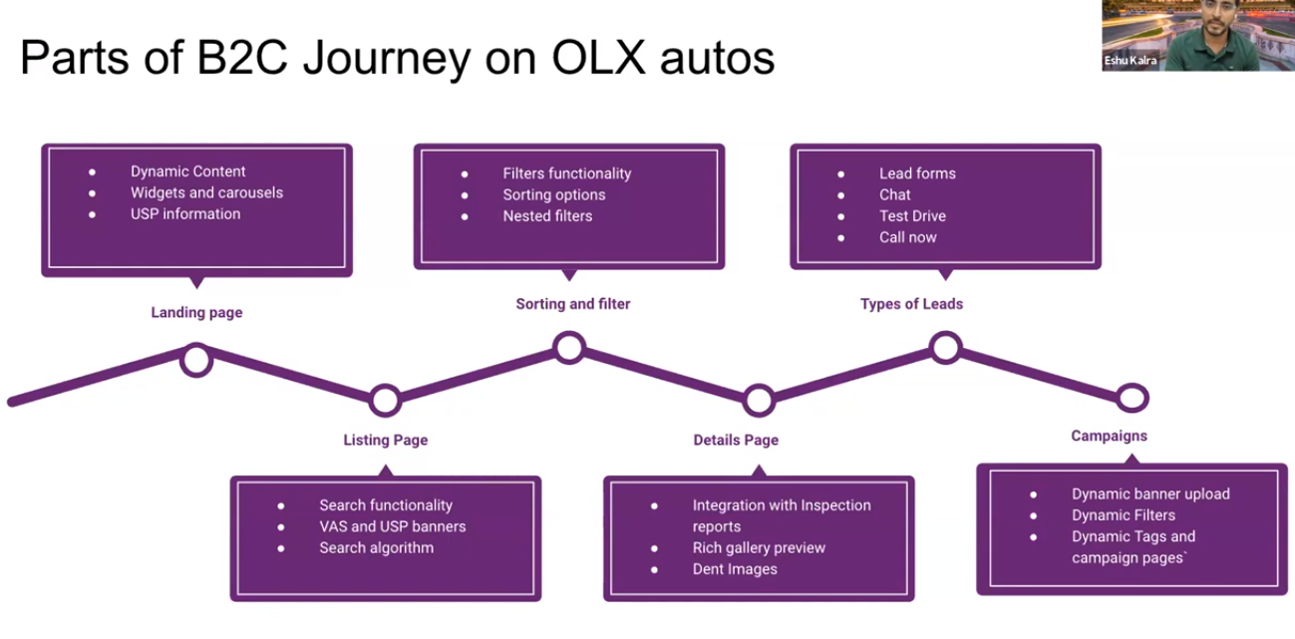

**Landing Page**

* Sell Page
* Buy Page
  + Buy Landing Page (5-6 segments)
    - Banner (Contains information, example information about campaign that is on going, tell people about what is the page about, etc)
    - 4 tabs (terkini, most popular, sesuai budget, lihat lagi) about the available items in the platform. To go from buying landing page to listing page, we can use the *List Mobil Sesuai Budget* tab and it will filtering the items based on the budget that we want.
    - Static page (tell information about the benefit of buying using Olx / USP)
    - Search item based on the budget
    - Search item based on the year
    - Search item based on the brand
* **Listing Page**
  + It has all the inventory. The items shown in this page is only the item that is posting by the dealer. Only dealers and franchises can post the ads.
  + Search segment : we can search an item in the platform
  + Location segment
  + Filters segment: range of the price and how many items within the particular price, model and brand (nested) filter ( will only show the model and or the brand that we picked)
  + Item part : price, model, fuel type, how many miles are covered, the location, favorite an item
  + Sorting by price (default will be by relevance)
* **Details Page**
  + Photos of the card
  + the name of the car
  + Information from the inspection record